**Raw data plots**

**lmer** then **emmeans**

**For composition**

model <- pmol_mg ~ time * group + (1 | id)

Assessment: Seems good.

**For Class**

pmol_mg ~ time * group + (1 | id) + (1 + time | lipidComposition)

Assessment: Seems OK to use. Trying to think if the variability within compositions would be an issue. But the issue would be the same when using sum. Therefore, approach seems good.

OR

pmol_mg_class_sum ~ time * group + (1 | id)

How to handle **non-parametric** data for some lipids?

Assessment: Not really any good solution to transform some compositions and not all. This approach could be OK, especially for an exploratory analysis.

**emmeans**

emm <- emmeans( model, ~ time * group)

**Slope results**

contrast(emm, method = "revpairwise", interaction = "pairwise", adjust = "none")

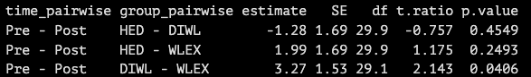

**Pre-post results within group**

pairs(emm, adjust = "none")

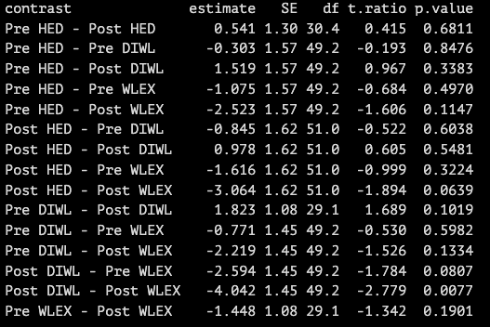

Assesment: Cool with emmeans! Adam did not know and learned something new!

**Spearman** for correlations between pre-post changes in clinical endpoints and lipidomics

E.g. Δlipid vs Δweight

Could clinical outcomes like weight and VO2 be used in **lmer** to make adjusted correlation estimates?

Like:

pmol_mg ~ time * group * weight * VO2 + (1 | id)

This somewhat “works”, but I find it difficult to interpret results

pmol_mg ~ time * group * weight + time:weight + (1|id)

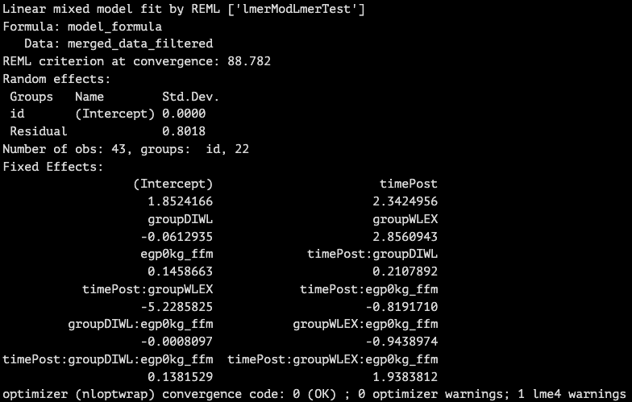

Assessment: Spearman seems OK. But not sure about more complex models. No experience with these.